Activity No. 4.4
Hands-on Activity 4.4: Characters and Strings
Course Code: CPE007 | Program: Computer Engineering
Course Title: Programming Logic and Design | Date Performed: 9 – 30 – 25
Section: CPE11S1 | Date Submitted: 9 – 30 – 25
Name(s): Paula Esguerra | Instructor: Engr. Jimlord Quejado
6. Output
- Write a program that creates a multiplication table using multidimensional array.

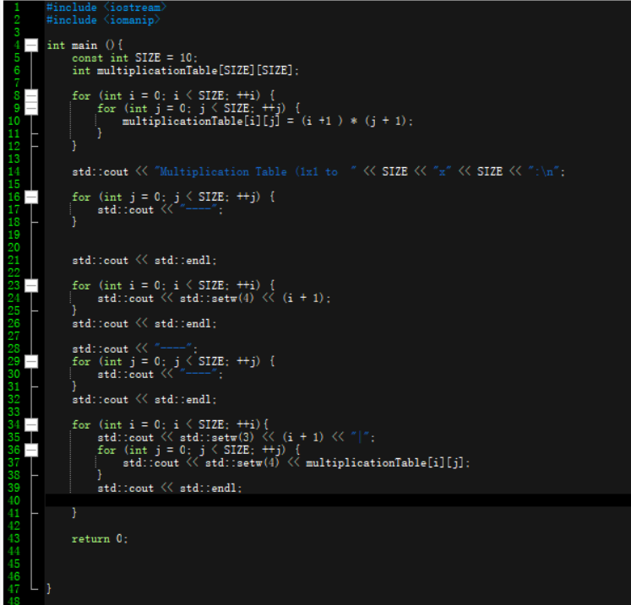
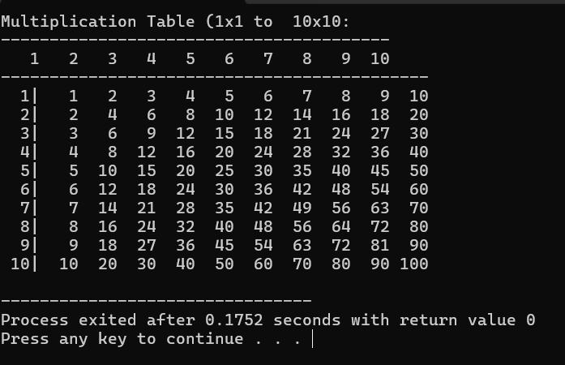

- Write a program that creates a board with a tic-tac-toe moves.

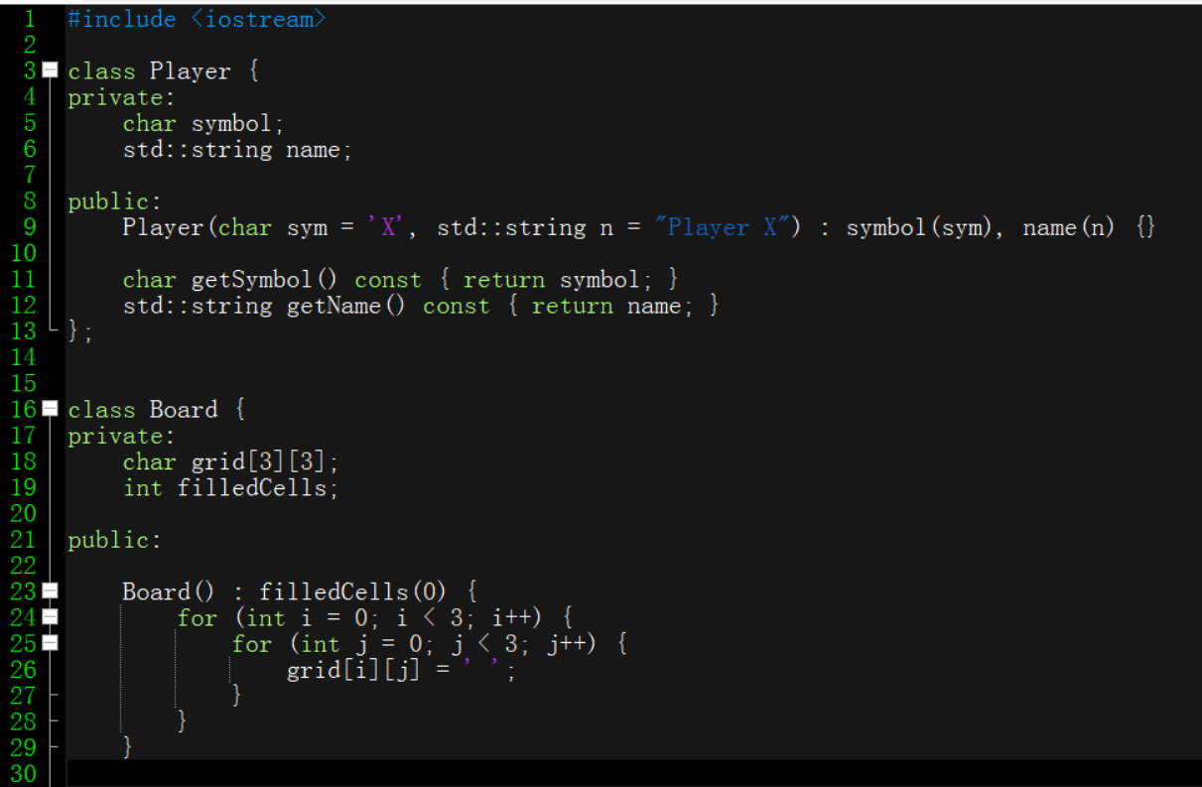
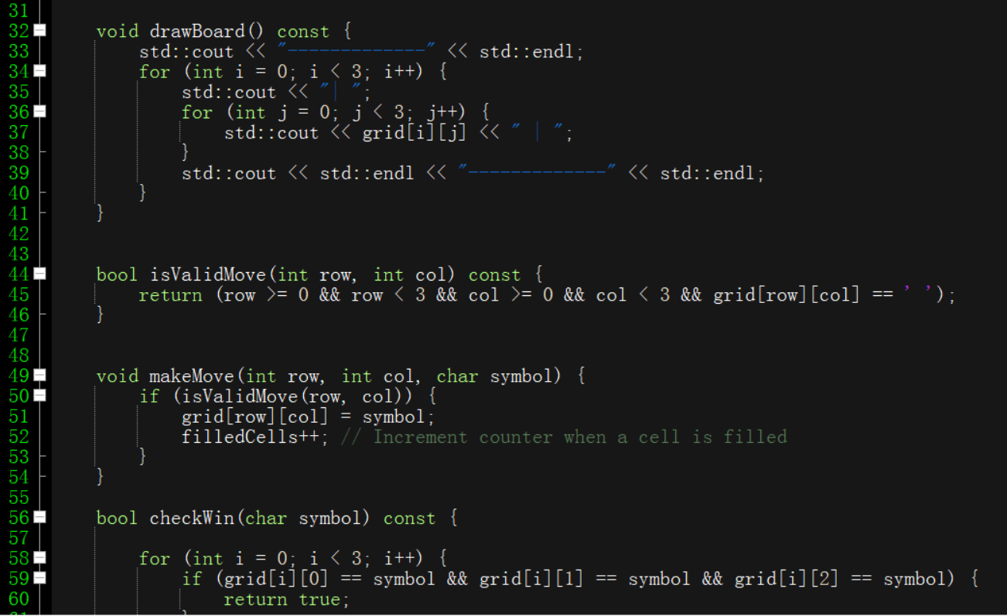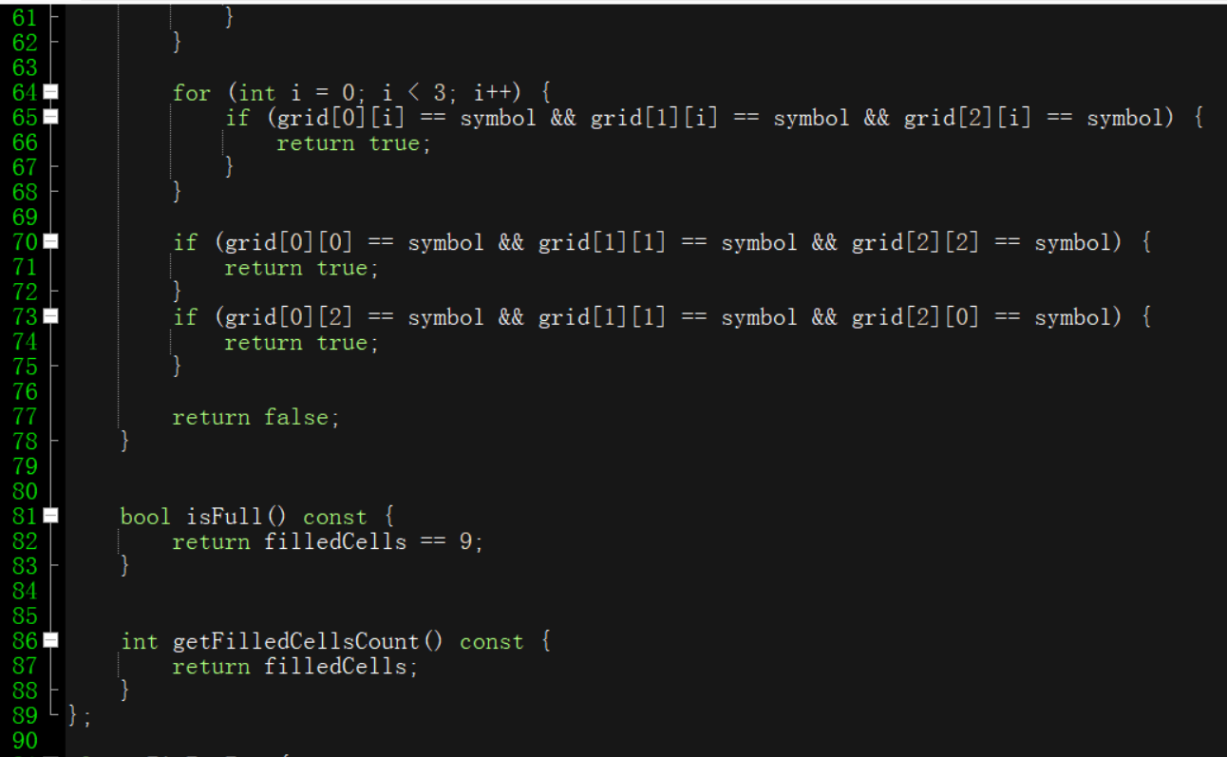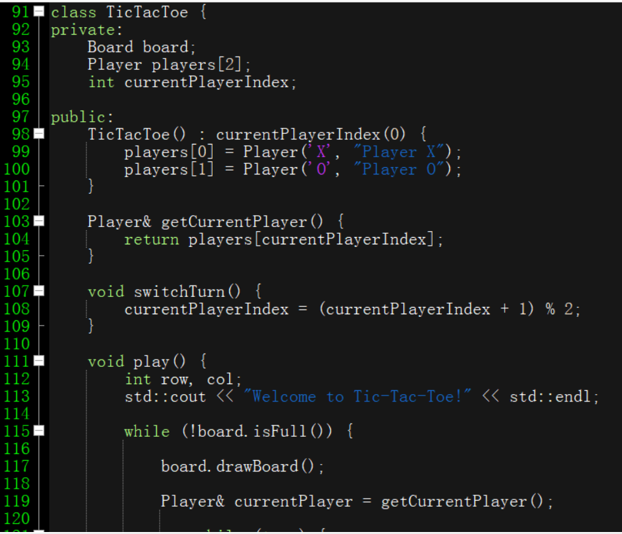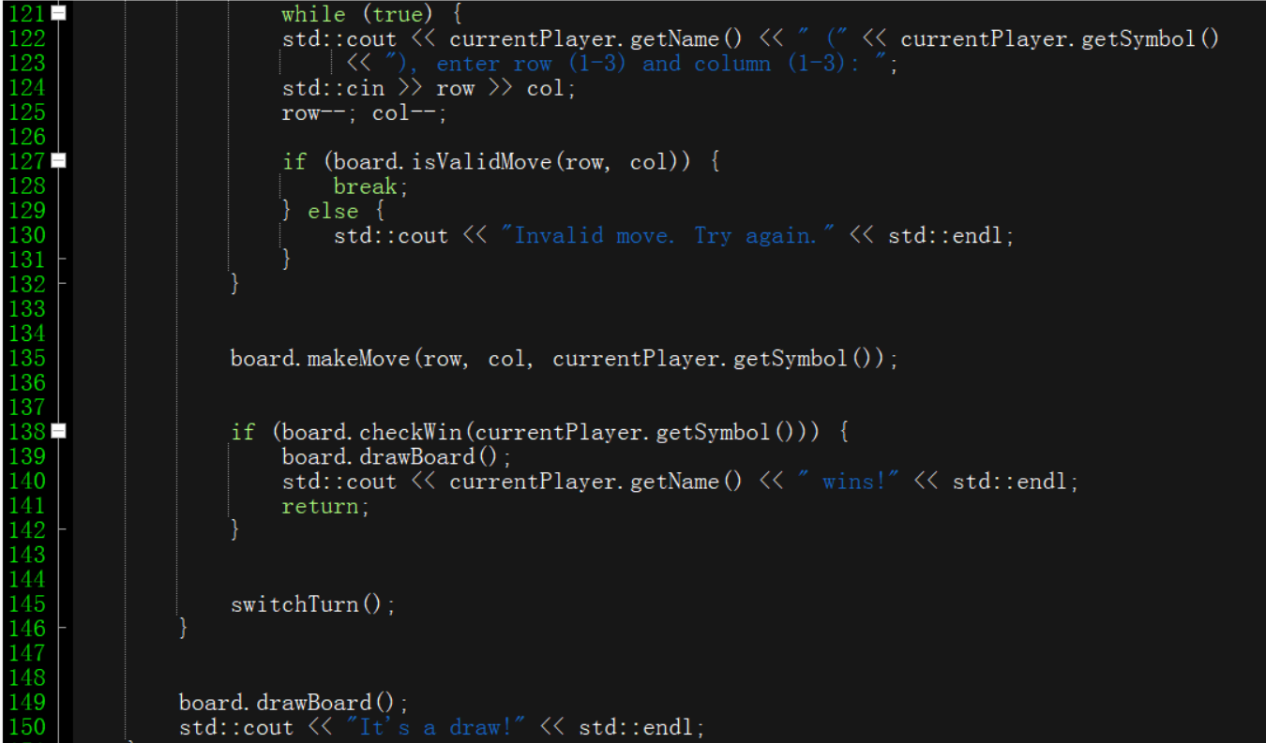
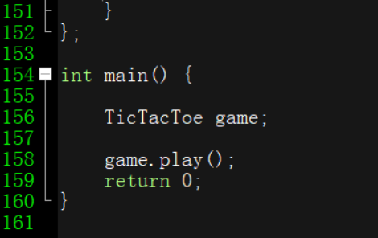

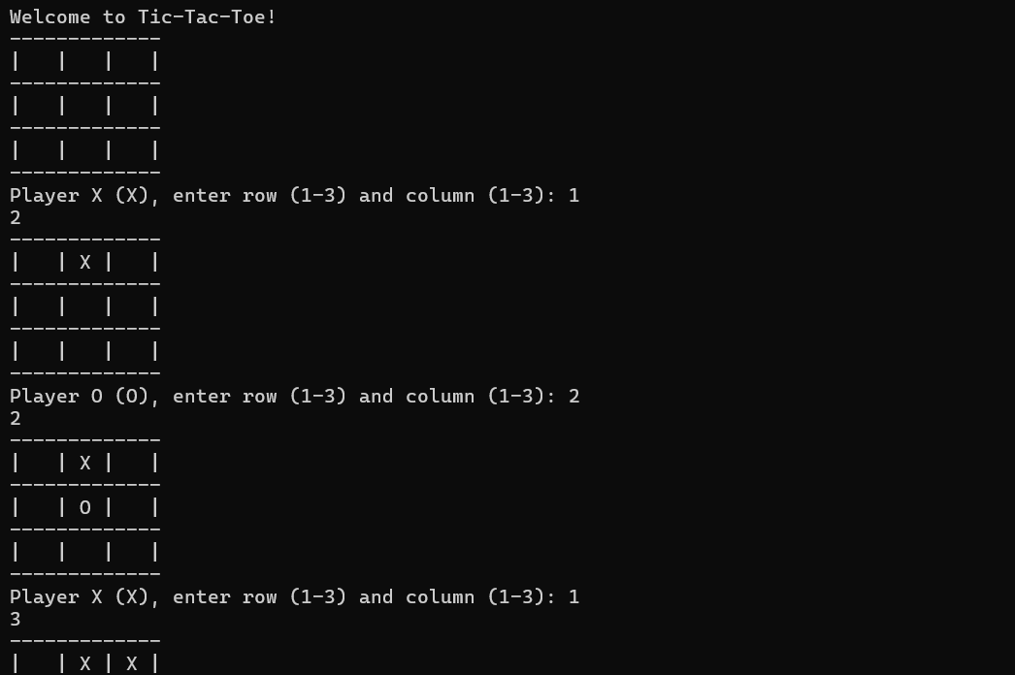
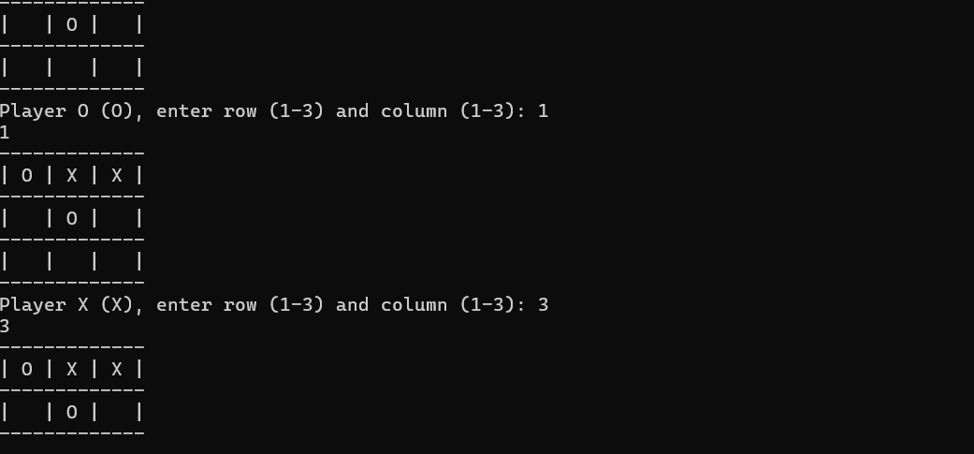
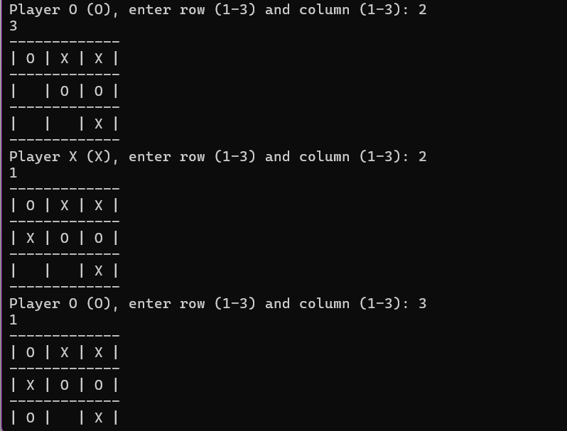
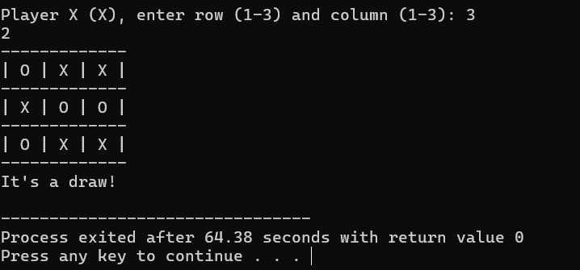

7. Supplementary Activity
1. Analysis
First I include iostream and iomanip. Iomanip is to manipulate input or outputs, to gain access to the format manipulators. Then used for loop to display all of the numbers between 0 to 9. So the body of the loop is executed and update expression is evaluated. The loop variable “i” and “j” goes from 0-9 for a total of 10 columns, 0 is part of the count. Then cout to print.

2. Analysis
Bool is a function to check if a player’s intended move is valid, if it is true then the specific cell is represented by the character made by the player. If it is false then it will show the intended print for it. It would made to be invalid. Char stores the character representing the player of the board. String stores the name of the player. While loop is to prompts the currentplayer to enter a row and column for their move.
8. Conclusion
In this code, I have practice how to use the columns and rows in the code. Though I still have to practice combining for loop, while loop, bool and void, I still have to get the basic out of it, even though I understood the code, I still have trouble using them. I learned that you could use a code to shortcut the method, but some of the doesn’t work on devc+ and I still have to figure out the error so I stick to what I have and learned.
9. Assessment Rubric

